**DAILY ONLINE ACTIVITIES SUMMARY**

|  |  |  |  |  |  |  |  |  |
| --- | --- | --- | --- | --- | --- | --- | --- | --- |
| **Date:** | **13-7-2020** | | | | | **Name:** | **poojashree** | |
| **Sem & Sec** | **8th sem A sec** | | | | | **USN:** | **4al16cs065** | |
| **Online Test Summary** | | | | | | | | |
| **Subject** | |  | | | | | | |
| **Max. Marks** | |  | | **Score** | | |  | |
| **Certification Course Summary** | | | | | | | | |
| **Course** | **Introduction to cyber security** | | | | | | | |
| **Certificate Provider** | | | **Great learning academy** | | **Duration** | | | **5.5hr** |
| **Coding Challenges** | | | | | | | | |
| **Problem Statement:** 1. Python Program for Reversal algorithm for array rotation | | | | | | | | |
| **Status:completed** | | | | | | | | |
| **Uploaded the report in Github** | | | | | **yes** | | | |
| **If yes Repository name** | | | | | **Poojashree** | | | |
| **Uploaded the report in slack** | | | | | **yes** | | | |

**Online test**

**----------no marks -----------**

**Certification course**

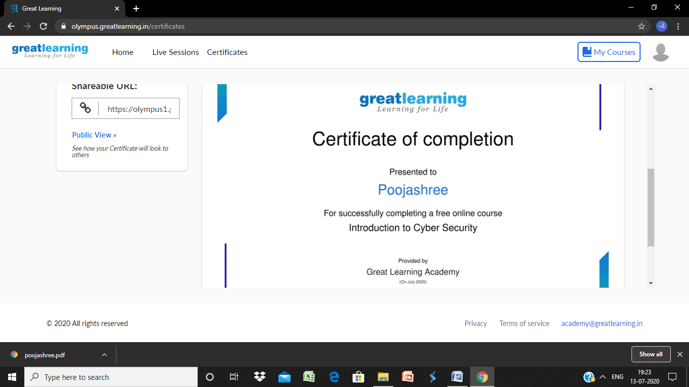

**Coding**

**Program 1**

def rverseArray(arr, start, end):

    while (start < end):

        temp = arr[start]

        arr[start] = arr[end]

        arr[end] = temp

        start += 1

        end = end-1

# Function to left rotate arr[] of size n by d

def leftRotate(arr, d):

    n = len(arr)

    rverseArray(arr, 0, d-1)

    rverseArray(arr, d, n-1)

    rverseArray(arr, 0, n-1)

# Function to print an array

def printArray(arr):

    for i in range(0, len(arr)):

        print (arr[i])

# Driver function to test above functions

arr = [1, 2, 3, 4, 5, 6, 7]

leftRotate(arr, 2) # Rotate array by 2

printArray(arr)